Create a Spring Web Project using Maven
Created a maven project using spring initializr and added required dependencies.
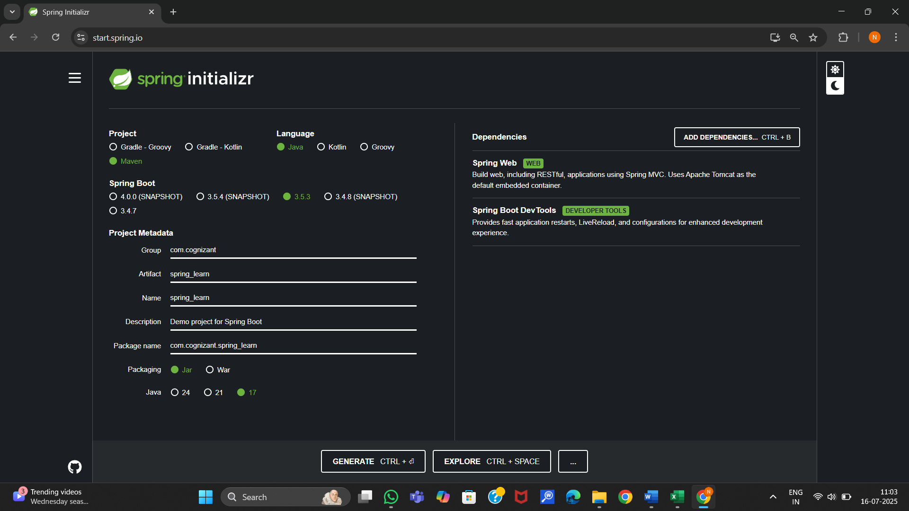
Clean up the maven project.
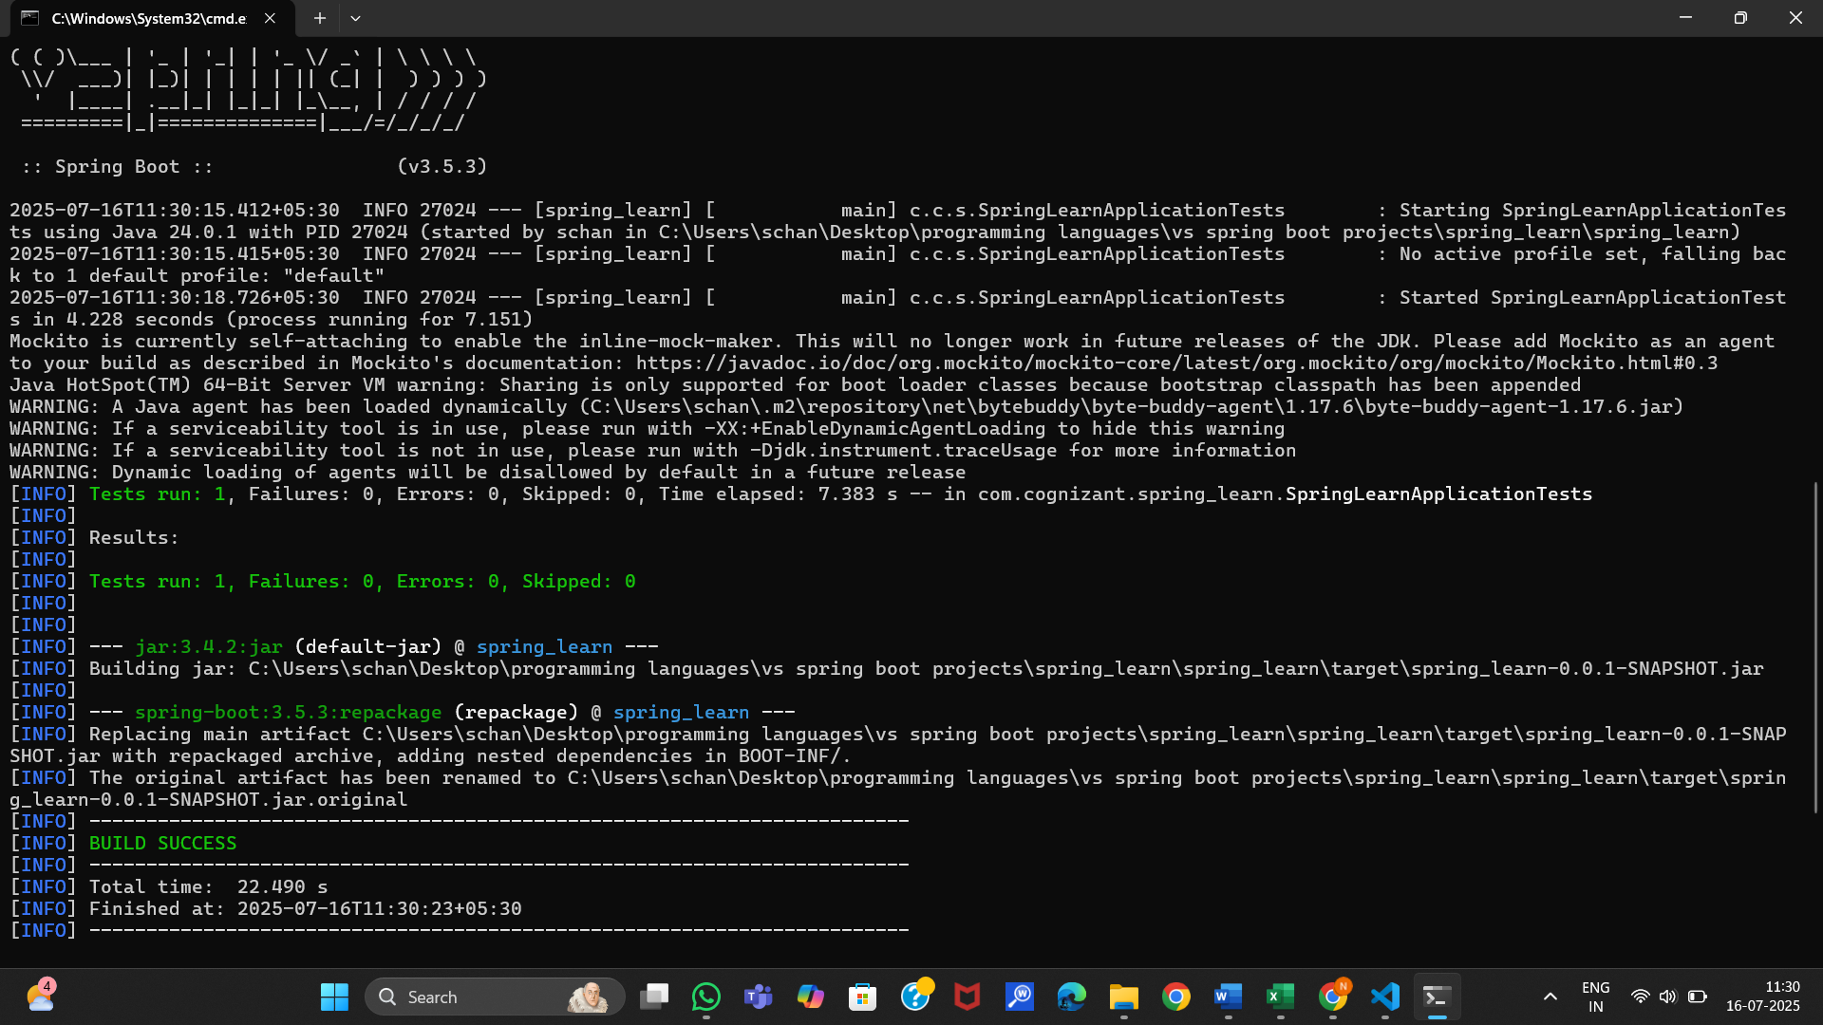
Opened the project in the eclipse ide.
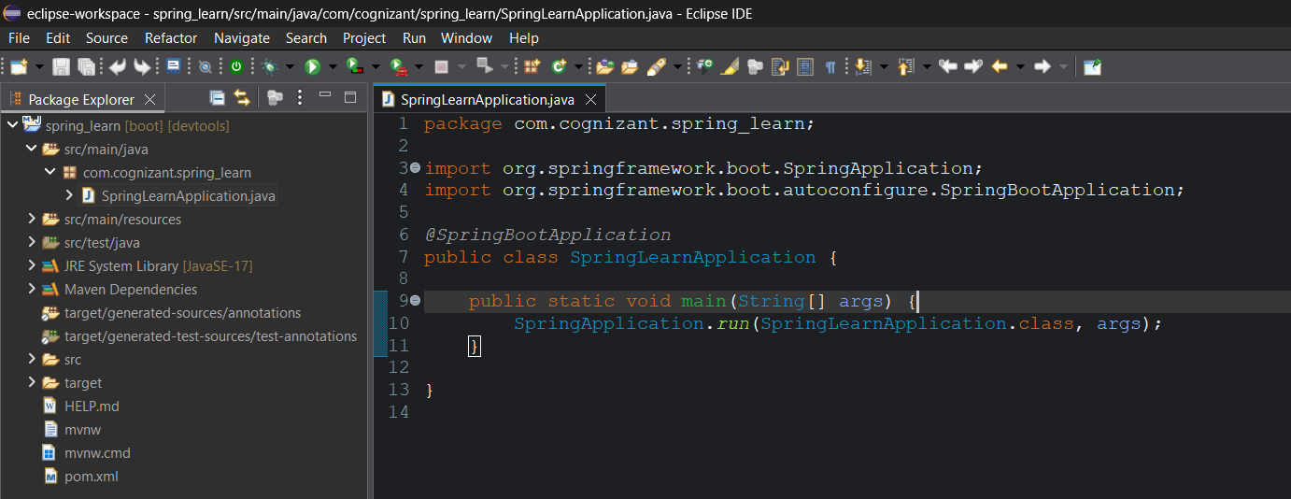
Added logs in the main()
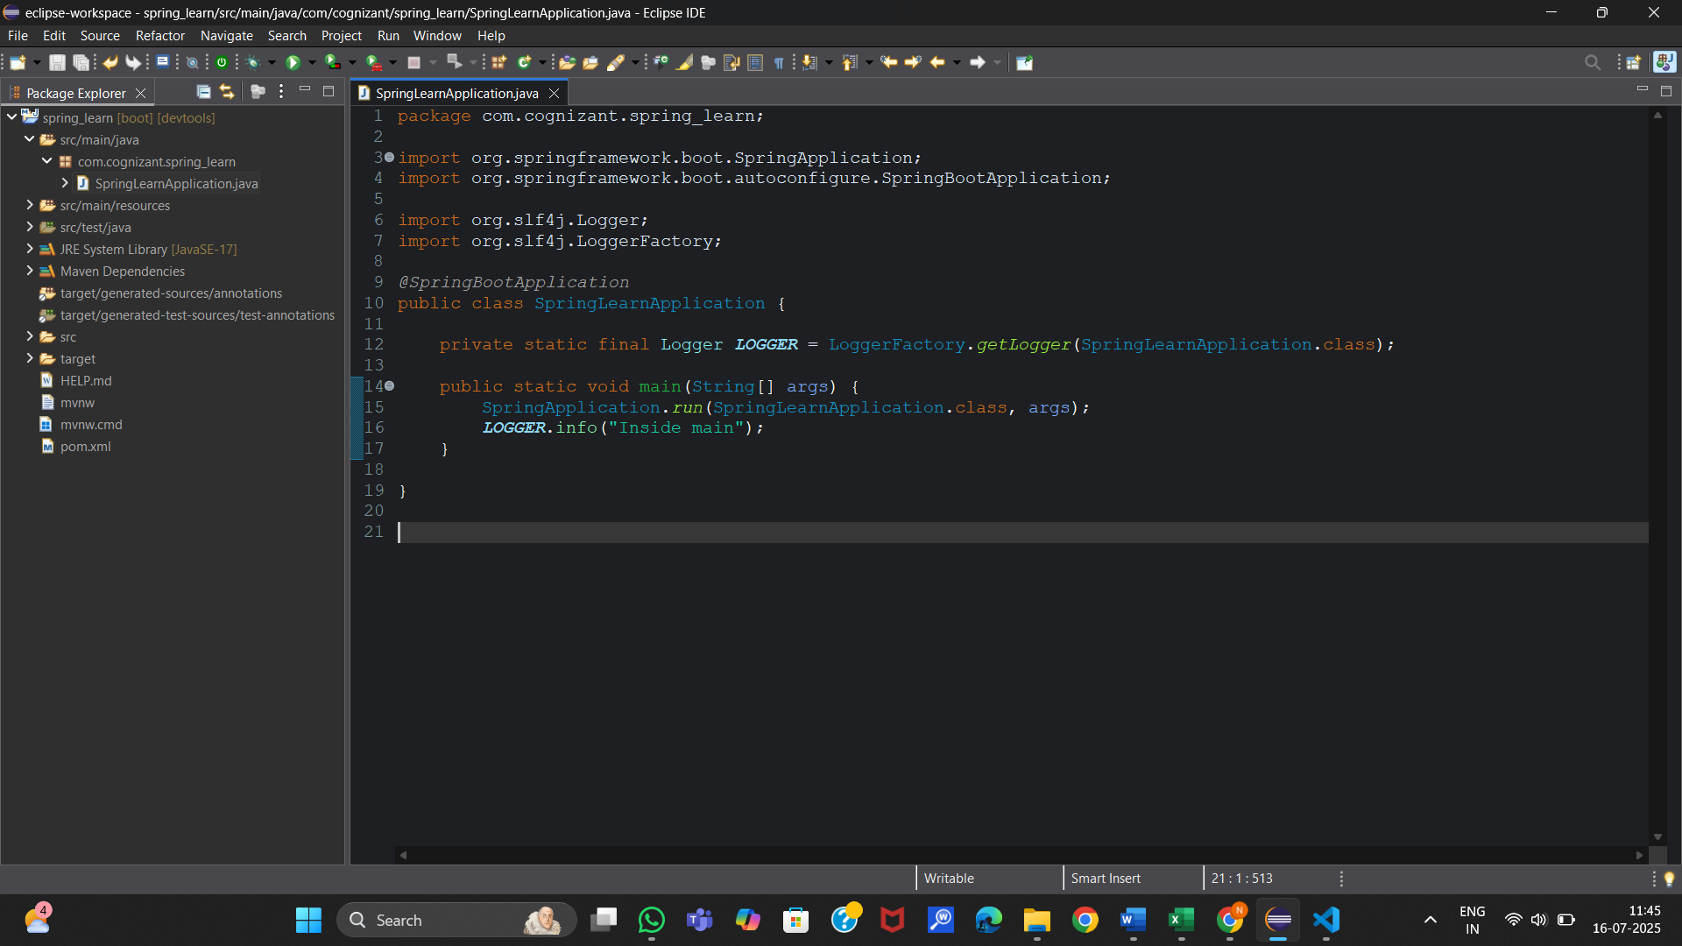
Run the main application
